**Mathematical modelling for biological systems.**

**Assignment 1**

**Praveen R**

**AM.BT.P2BIF20022**

Installing Ubuntu on the machine

* Creating Bootable device
  + - * + We use Rufus to create bootable USB device

* Download Iso file of Linux distribution Ubuntu:

* Create Bootable media drive using Rufus

* Select the path of downloaded iso file

* Set the parameters: Partition scheme to MBR and Target System to BIOS or UEFI and apply start

* Bootable Media is Created

After creating the bootable device restart the device and open boot Manager (ESC, F9, F11). Select the media device .

* System will start the installation process -Select install ubuntu

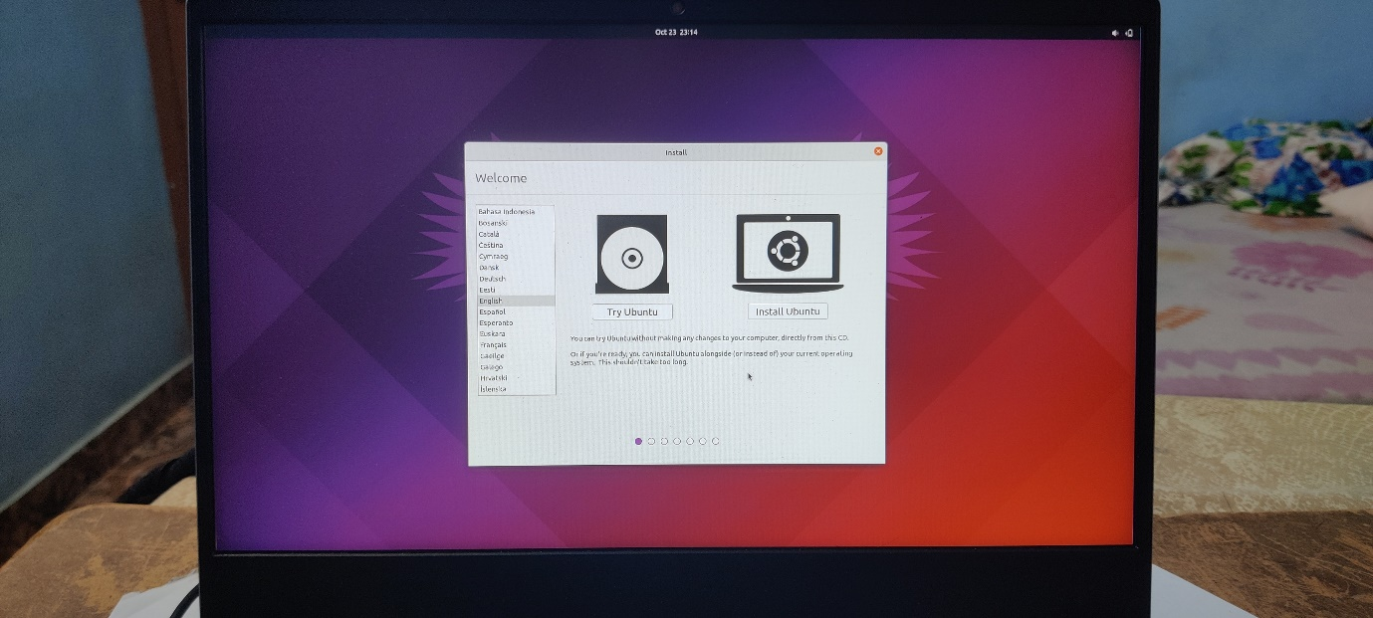

* Selection of partition where ubuntu need to be installed .

* After selecting the Disk partition, the OS start installing in the specified drive. after installation restart the device

* System will ask you to select the operating system of choice since I have installed two operating system inside the machine.

B) Installing Third operating system into the machine

* Download iso file of Zorin OSGraphical user interface, text

  Description automatically generated
* Creating bootable device using Rufus .

* Restart the system and open Boot manage A computer screen with a blue background

  Description automatically generated with low confidence
* Select the media devices from the list

* System will initiate the installation process of ZORIN operating system

* Select Install ZORIN OS to disk option

* Select the parttion to which os has to be installed

* After successful installation restart the machine and remove the media from machine.

* Now the machine is installed with three operating systems ZORIN OS , Ubuntu, Windows 11.
* Python program in ZORIN OS

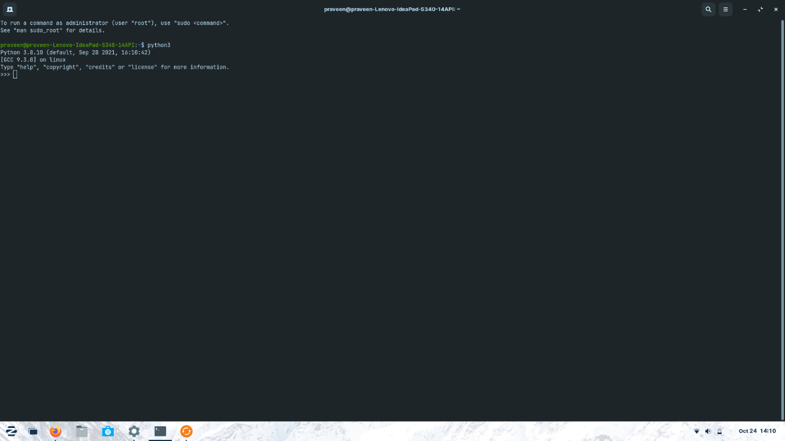

2. What is Shell and Kernel ? what are there functions?

* Kernel and shell are parts of Operating System.
* Shell – shell takes the request given by the user for performing some operations and it will convert the Human understandable program/language to machine language, hence shell is also called interpreter.
* The kernel is a computer program which acts as the core of the computer’s operating system and has the control over everything in the system. A shell is a computer program which works as the interface to access the services provided by the operating system.
* Kernel is responsible for the processing of request that it gets from the shell . Kernel performs several operations like it checks whether the process is running or waiting, It allocates and de-allocates process, when a kernel determines that the logical memory does’nt fit to store the programs then uses the concept of physical memory and store into temporary manner., kernel stores files into computer systems such that no one can read or write the files without permissions.

3. What is Operating System?

* Interface between the computer hardware components and user.
* Applications need environment to perform task and operating systems are necessary to run these programs.
* Processing of data, running applications, file management and handling the memory is all managed by the computer OS

